

Brand Measurement Framework

Date: | Aug 28, 2025
Ax DRI: | Moshe Katzwer
Ax Reviewer: | Linsha Chen
Ax/Martech WG: | Moshe KatzwerVinod BakthavachalamLinh NguyenFelix RiveraZheli He
Stakeholders: | Gina IgweJennifer RichardiEvelyn Lopez MendozaAndy WellsGun JohnsonJessica LachsMonica TamMeredith Teisseyre

TL;DR:
- In Q3 and Q4, Paid Marketing Ax is making a concerted push to better understand “brand”:
  - What is the impact of brand marketing on business outcomes?
  - To what extent are brand health (or other short-run proxies) leading indicators of business performance?
- In addition to our internal data, we have several data sets that are relevant to these questions – none of which can be used in isolation to answer these questions. These data sets include Kantar Brand Health Survey (which tracks brand health over time), the Brand Lift Surveys (which estimate brand lift from media exposure), and Liveramp/Vizio TV exposure data.
- There is no “silver bullet” model that fully answers our questions on brand. In this document we present a portfolio of projects intended to answer parts of the above questions.
- Our major proposed projects for Q4 are
Project | Data Source | Deliverable | Use Case(s)
BLS Deep Dive | Kantar/Wavemaker Brand Lift Study | Systematic estimation of how brand media moves brand health month-over-month using monthly report data. | Optimizing brand media tactics towards different brand objectives  Understanding cost of brand health lift
Linear TV Incrementality Model | Liveramp/Vizio TV data,  Internal Data | Short- and Long-run estimates of business impact of TV exposure | Calibrate/replace iSpot for TV. (If successful, extend to OTT and other media.)  Quantify relationship between brand media and long-run business outcomes  Combine with BLS to understand brand health lift predictiveness of longer-run outcomes.
Leading Indicator Model | Kantar Brand Health, Google Search Data, Internal Data | Estimates of the long-run (6-12month) predictive power of brand health metrics and other potential proxies/leading indicators like visits or google search volume. | Understand the degree to which the current variation in brand health metrics reliably predicts business outcomes, if at all.  Tie future value to marketing efforts that shift leading indicators (e.g. brand media moves search now which correlates with GOV in X months).  Note: We have lower confidence here. Any quantification of “brand equity” is out of scope.
See Detailed Project Descriptions for a fuller discussion of proposed projects, staffing and risks.
- Paid Marketing Ax is very bandwidth constrained (6 IC FTE, with 1 recent exit, 3 weddings in Q4). Accelerating work on these projects necessarily implies tradeoffs in our LOB and platform support.
- Measuring the long-run effects of anything is difficult. Measuring the impacts of paid media is difficult. Measuring the long-run effects of brand media is exceptionally difficult. We have varying degrees of confidence in our ability to answer these questions in an actionable way.
  - Past attempts at understanding brand health value have ended inconclusively or inactionably.
  - We have medium confidence in the TV modeling and the BLS deep dive, low confidence on direct brand health work.
  - We do not want numbers that we lack confidence in to be used without proper context.

Discussion Topics for Alignment:
- As a group do we agree with the portfolio of projects here? Which should be prioritized/deprioritized?
- Do we agree with the proposed sequencing?
- Resourcing/Staffing

This document outlines Ax’s proposal for “brand” data science work in 2025’Q4 and beyond. In Summary, we briefly outline the questions that we are trying to answer and our high-level ensemble approach. In Data Sources, we give more detail on the exact data sources that are available (as well as some open questions). In Q4+ Plan & Resources we outline a tentative roadmap and resourcing. In this section we give a high-level overview of each sub-project, highlighting methodology, dependencies, and risks. Finally, in Tradeoffs we highlight our limited staffing on Paid Marketing Ax and the need for some ruthless tradeoffs in prioritization.
Note: Ax will approach this ensemble of projects with an open mind and positive intent, but is also flagging for the record that there is a risk that these projects may end inconclusively. This is a genuinely difficult statistical inference question, with few prior examples of it being answered very convincingly.

Summary
Brand can be an overloaded term; it refers both to brand investment (that is paid marketing initiatives that are geared towards shifting brand perceptions), as well as a broader concept capturing consumer sentiment about Doordash as a whole.
We currently spend over $260M a year on the so-called “brand” media and investments, which is dedicated towards driving first choice consideration in priority audiences. We are looking to expand this spend. This spend is typically invested on top of funnel channels like TV, OOH, Paid Social and cultural integrations / partnerships that allow for more meaningful engagement with our target audiences. The intent of these investments is to raise brand awareness or consideration, rather than explicit “call to action” (CTA). The belief is that while this media might not be as efficient as performance-media in the short-run, it is planting medium- and long-run seeds that will pay off over time. Note that brand marketing is also not just media–we spend significantly on real world physical interventions like “Paint the Town Red”. In 2026, we intend to increase our investment in this bucket as we strive to make DoorDash an unmissable brand that owns key cultural moments.
More broadly outside of marketing use cases, there are many non-marketing events and initiatives that plausibly drive brand health. Understanding “brand” is not narrowly of interest to marketing – leading indicators of business health (brand health or other proxies) are important even if not immediately actionable.
There are two key questions around “brand” that we are trying to answer:
- What is the (long-run) business impact of brand marketing investment?
Use Cases: Optimizing marketing spend/tactics across brand channels (and other initiatives like PTTR), and balancing investment across brand and performance.
- What is the (long-run) business value of “brand health”? (as measured in our brand health surveys)
Use Case: Leading indicators of business outcomes, aggregate impact reporting of brand health initiatives across the company.
Both of these questions are challenging, there is no perfect data set or experiment that gives you a robust answer. Estimating the long-run impact of any intervention is typically difficult, brand investment is not unique on this front. Estimating the impact of marketing is difficult. Marketing + Long Run impact is doubly difficult.
The second question on brand health is even more difficult because it entirely relies on survey data. Brand health is influenced by many factors (not just marketing investment, or even broaderly, any efforts within DD), and there is a lack of user-level visibility and variation to really tie brand health movements to outcomes.
By contrast, the first question is more tractable, actionable, and has a higher likelihood of yielding meaningful insights because we have more ability to work at a user level and correlate outcomes with actual actions that we take.
Because of this, we are recommending a multi-pronged approach, there is no silver bullet that fully answers this question. Our best hope of a holistic answer is an ensemble of several models and data sources that in aggregate could give a full picture.
The data sources that we will leverage include:
- Kantar Brand Health Survey (BH), a monthly survey of ~2k food delivery users tracking health metric including DD awareness, Dashpass awareness and consideration.
- Kantar/Wavemake Brand Lift Study (BLS), a continuous survey of ~2k adults tracking brand health as well as exposure to brand media.
- Liveramp+Vizio+AIQ (“Liveramp”), user level data on demographics (AIQ) and linear TV exposures (Vizio) mapped to our users (via RampID). We currently only have TV exposures data, but if needed, can purchase OTT exposures.
- Internal data on potential short-run proxies/leading indicators including organic visits, google branded clicks, google search volume, and email opens.
In Detailed Project Descriptions, we outline a portfolio of brand-related data science projects. In that section, we dive in greater detail to specific projects. Here, we give a high level summary of how the data above will be used to answer our key brand questions:
Question | Data | Project:  Deliverable: | Timing
What is the short- and long-run business impact of brand media?  Brand Overall | Internal User-level data  Vizio TV panel  AIQ demographic data  (OTT panel [TBD]) | Project: User-level synthetic control modeling comparing exposed and unexposed users over short- to long-run time periods.  Deliverable(s): Causal estimates of business lift from brand media exposure.  Note: The initial phase will use linear TV data. If successful, we can expand the approach to OTT and brand social. We are prioritizing TV because (a) the data is in-hand, (b) we are blind on TV while OTT/social have some experiments/testing, and (c) linear TV has some of the strongest BH lifts in the BLS.  Note: Combined with BLS, this modeling will also tell us about the linkage between short-run brand health lifts and long-run outcomes. | Q4/Q1
 | Internal User-level data  Ad-partner clean-rooms | Project: User-level AB experimentation  - Peacock (NBC)  - Disney+  - Meta (social)  Deliverable: Incrementality estimates for select brand channels. iSpot calibration. | Q4/H1
What brand media channels and tactics lead to brand health lift?  Brand Overall | BLS Survey  Spend and reach data | Project Phase 1: Correlating in monthly/quarterly survey reports BH lift with spend/reach by channel. Defining heuristic for mapping BLS lift to aggregate “BH” changes.  Project Phase 2: Deep dive on respondent level data.  Deliverable: Report on (potentially qualitative) marketing insights to guide brand media decisions. | Phase 1: Q4  Phase 2: Q1
What brand health metrics or other short-run proxies (like search volume) are leading indicators of business performance?  Brand Overall | BH Survey  Google Search Volume  Other Internal Data | Project: DMA x month time-series modeling  Deliverable: Quantification of what extent (if any) brand health metrics or other leading indicators predict long-run business outcomes. | Brand Health: Q3  Proxies / other leading indicators: Q4
What is our growth rate among priority audiences (e.g. Hispanic) who are targeted by specific brand marketing?  Audience Specific | Internal User-level data  AIQ demographic data  Internal Hispanic user model  Internal Parent user model | Project: So-called “Audience Growth Engine”  Deliverable: Descriptive time series comparisons of our relative growth rate among high-priority audiences (relative to general population) leveraging Liveramp/AIQ tagging. | Q3/Q4
What is the brand health and business impact of brand marketing investments that is not just media, like “Paint the Town Red”. | Internal data (i.e. short-run proxies or leading indicators)  BH Survey | Project: “Paint the Town Red” measurement plan and strategy  Deliverable: Geo measurement of brand health and business metric lift from deployment of branded Cx/Dx/Mx swag and other prominent marketing displays in select DMAs. | Q4/H1
Long-Run Business Impact
BRAND MARKETING
BRAND HEALTH
TV Incrementality Modeling (Q4)
Meta Brand Social Experiments (2026)
Paint the Town Red (2025-2026)
OTT experimentation
Aggregate BLS Analysis (Q4)
User-level BLS Analysis (H1’26)
Brand Health + Proxy Time Series Analysis (Q3/Q4)
This list is not exhaustive–there is interplay between some of these elements. (For example, combining the TV exposure→Brand health lift estimate from the BLS with the TV→Business impact number from the TV model implicitly tells you something about the value of brand health lift.) Again, we repeat that these projects are aspirational – we do not guarantee success. (In Q4+ Plan & Resources we discuss our confidence in more detail.)

Tradeoffs
The Paid Marketing Ax team is significantly under-resourced in Q4, with 3 people getting married, and 1 person exiting. To expedite brand work, we NEED TO make trade-offs on top of already constrained resources. Q4 planning has not happened – so additional tradeoffs will need to be made as requests come in.
Putting Vinod Bakthavachalam 100% on “brand” will require shifting his USMP commitments to Zheli He (who owns the related PTTR), and will require USMP tradeoffs.

Appendix

Data Sources
Below we elaborate on the data sources we have, use cases, and other notes.
Description | Potential Use Case(s) | Pros / Cons | What do we need to explore further?
Kantar Brand Health Survey (BH)  (See for example the report here.) This is an ongoing survey of on-demand food delivery users, tracking the evolution of health metrics like consideration, awareness, Dashpass savings awareness, preference, etc. We currently have response data aggregated to the DMA x month level, and will explore securing more granular data if available. The survey is not large, typically on the order of 2,000 Doordash core survey respondents, and 750 respondents a month. | Brand Health → Business Correlation | Pros:  Aggregate directional view of brand health evolution  Cons:  Respondents are not continuously tracked, and change every month.  Movements not directly attributable to DD initiatives.  Very little variation (at least in national average) over the last several years in these metrics. | We are asking Kantar if respondent level data is available (as in BLS). We need to determine if the respondent level data has any PII we could map to our internal user dataset.
When we say there is very little variation in the Brand Health Data over the last few years, look at First Choice Consideration (left) and Brand Unaided Awareness (right) from the Q1 BH report.
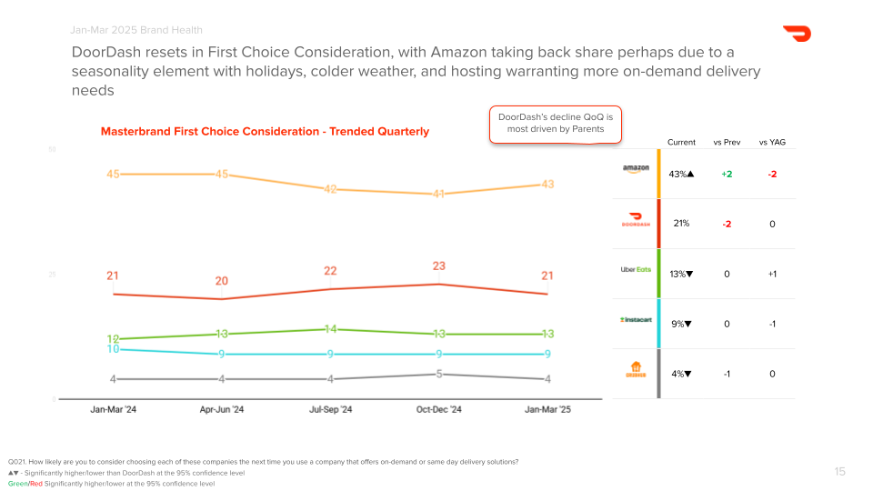 | 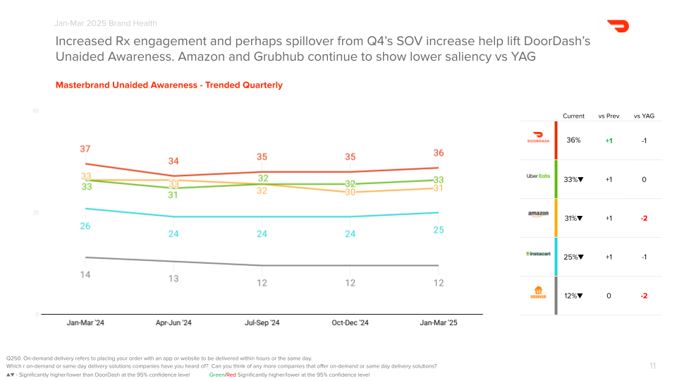

Kantar/WM Brand Lift Study (BLS)  (See for example this report.) This is an ongoing survey of the general population. We typically ingest monthly and quarterly reports. The monthly report has on the order of up to ~2.5k respondents. This survey compares users who were exposed to different types of media (social, TV, etc) with an unexposed “control” and estimates the brand lift. [In theory this is weighted via some sort of synthetic control.] We also have access to respondent level data in addition to the monthly/quarterly summaries. | Brand Media → Brand Health  Marketing Optimization within and across brand | Pros:  Responses actually split by media exposure at a fairly granular level.  Gives you health differences in the cross-section based on exposure, while BH is entirely time series variation.  Cons:  Respondents are not continuously tracked and change every month.  No direct data link in BLS to business metrics. | Martech is currently scoping the ingestion/validation of the respondent-level feed.  We need to understand the weighting methodology that Kantar uses when constructing “comparable” exposed and unexposed cohorts.  This data might include IP address/device ID. In theory there is the potential to map this data to Liveramp and therefore assess brand lift directly for example by looking at Vizio exposures, or Meta brand media exposures in the Meta AA cleanroom, etc. This needs to be scoped and validated.
To give an example of the (monthly) data reports that we get in Kantar BLS, they report on the lift in brand health between exposed and unexposed users as in the below screenshot. We have access to much more granular underlying respondent-level data that has richer demographic features, details on media exposure type/creative/times, etc, as well as the weights Kantar uses to construct “comparable” groups.

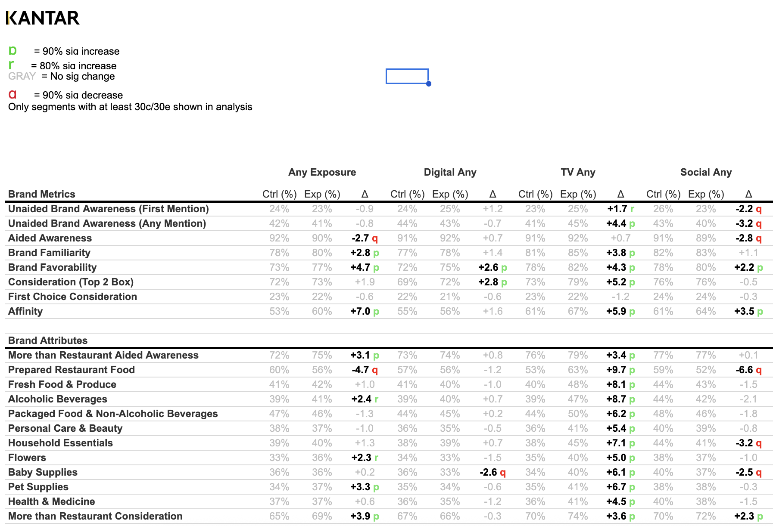

​​Liveramp + AIQ + Vizio (“LR”)  We purchased a weekly-updating panel of ~150M US adults which are mapped to our internal users via a “RampID” matching technology. Using this matching, we can then assign demographic features (via AIQ) and TV exposure data (via Vizio). The intent of this data in the near term is (1) to quantify our relative growth rates in priority populations versus the general population and (2) build out econometrics modeling to estimate the impact of linear TV exposure. | Brand Media → Business Impact  Differential Growth rates in priority audiences | Pros:  Large data set of TV ad exposure and viewing behavior that can be directly mapped to our users.  Cons:  Currently limited to linear TV. If the approach is successful, we can investigate expansion to OTT and social.  No brand health data directly. | If successful, such a model could be extended to other media types. In theory this dataset could be expanded with OTT data.  We are still validating the quality/match rate of AIQ demographic data.  Have not even begun to look at Vizio TV panel match rate and size.  Need to investigate the extent to which this can be mapped to BLS respondent level data.
Internal Short-Run Proxies  There are several internal data signals of potential usefulness to supplement the brand health metrics as short-run proxies of brand sentiment/health/intent, including  Organic visits / downloads,  Intentful visits,  Brand search volume,  Brand search clicks,  Email clicks/opens. | Brand Investment → Business Impact  Forecasting | Pros:  Rich internal user-level data with actual variation.  Cons:  Tying these surrogates (a) to brand marketing and (b) to business impact will be a challenge, (as with the brand health data). | To what extent if any do these proxies (a) correlate with brand marketing initiatives and (b) the extent to which they correlate in the medium/long run with business outcomes.



Detailed Project Descriptions

Q3 “Audience Growth Engine” (AGE): Are we growing our priority audiences?
Ax DRI | Vinod Bakthavachalam (~2 weeks, Q3)
Major Stakeholders: | Monica Tam, Evelyn Lopez Mendoza
Data Source(s): | LiveRamp, AIQ, Internal Data
Deliverable: | [1] Dashboard with differential growth rates for priority audiences (e.g. Hispanic, Gen-Z, parents, etc) that we feel comfortable displaying based on sample size. This gives us a holistic view on differential growth between these audiences and general population, but note that it is not envisioned at this stage to have any attribution. This is an overall view into audience growth.
Methodology: | This is purely a descriptive measurement tool – there is no heavy duty modeling here. We essentially join our internal user-level data with the Liveramp+AIQ demographic panel, and we can then report on any business metric we want, segmented by AIQ tagging.  There is discussion for expanding the scope here in future quarters to make this a more precise measurement tool for certain attribution use cases, but that is not in scope for this doc.
Risks Low | We are still validating the AIQ demographic data quality against our internal models for Hispanics and Parents.  Given preliminary views of the data, it is highly likely that directionally the AIQ data is correct (i.e. it gives us the right differential growth rate), but targeting use cases that depend on very precise user-level tagging might be more suspect.
Dependencies: | Potential LR support needed for understanding data issues, otherwise none.

Q3/Q4 Brand Health + Search: Leading Indicators of Business Performance
Ax DRI | Linh Nguyen (30% in Q3, 20% in Q4, ~5 weeks)
Major Stakeholders: | Gina Igwe Jennifer Richardi
Data Source(s): | Kantar Brand Health Survey (BH), Internal Data
Deliverable: | Quantify the correlation (if any) at the DMA level over time between  - Brand health survey metrics (consideration, awareness, etc)  - Other short-run proxies (search volume, visits, etc)  and long run (6m, 12m) business outcomes (orders, GOV). This quantification gives us a currency for valuing brand health (or other proxy) movements in the short-run.  [1] Ordinal ranking of which brand health or proxy metrics as most predictive  [2] Predictive correlations of the “value” of short-run movements in those metrics.  Note: Given that Linh Nguyen has already spent time analyzing the DMA-level BH survey data, we intend to deliver the report that we initially promised on the quantification of the relationship between BH and long-run and our confidence assessment. That direct brand health work will sunset in Q3, with Q4 focusing on other short-run proxies.
Methodology: | Time series regression modeling with deaseasonalization and other exogenous controls. First stage penalized regression for feature/lag selection narrows the set of potential predictors. Second stage regression modeling using narrow features to do actual quantification.
Risk High | Lack of movement in BH survey as well as small-sample respondent data at DMA level, as well as previous attempts at this type of work, means there is a sizable risk that this comes back inconclusive for brand metrics. Similarly, the faster cadence and smaller lags between actions/conversions at Doordash (relative to previous work where the proxy method has been successful) potentially means this “surrogate” type leading indicator methodology is less insightful.  Previous work in this area has proven inconclusive or unactionable, and it is unlikely that we can improve on those results.  Ax may not sign off on using these outputs for goaling or reporting.
Dependencies: | None

Q4 BLS Aggregate Result Analysis: What is the cost of brand lift?
Ax DRI | Linh Nguyen (15% in Q4, ~2 weeks)
Major Stakeholders: | Jennifer Richardi, Monica Tam, Gina Igwe
Data Sources: | Kantar BLS, (potentially) internal data
Deliverable: | [1] Quantification of the “cost” to drive movement in brand lift metrics utilizing the BLS monthly reports. (V0 of cost-per-BH-lift that might be improved in a respondent-level V1 model, pending data.)  [2] Data-driven heuristic rules for combining audience lift data in BLS with reach data to arrive at the share of the brand health movement “driven by” brand media initiatives.
Methodology: | The BLS monthly reports, taken at face value, do give us a cross-sectional split between exposed and unexposed users against which we can correlate our spend in those survey periods. Taking Kantar’s reweighting at face value, this allows us to directly correlate spend with brand-lift at a respondent level.  To map that to aggregate brand health, we will need to define a heuristic based on population sizes (no survey population, the population being sampled), reach, and spend, to define rules of the form “X pts movements in BLS cost Y and drove Z movement in aggregate, yielding a cost of aggregate brand health of W”.
Risks Medium | Since we are using aggregate data, we will need to accept Kantar’s reweighting scheme between exposed and unexposed users at face value. This is not experimental evidence, it is all observational, so you really need to believe that the exposure cohorts are made “comparable”.  In the BLS data, when we look at channel aggregates, i.e. the differences between exposed and unexposed based on X media, it is not uncommon to see stat sig negative lifts. We will need to systematize this a bit and take a stand on whether these lifts are noisy but directionally positive, or truly random.  Without doing the work above, it is difficult a priori to conclude how reliable this will be.  BLS results are only interesting insofar as they contain information not measured in other short-run performance measurement. If brand lift moves proportionally to measured performance lift, there is no net add here.
Dependencies: | Need accurate spend data categorized and aligned with BLS media categories. Need accurate reach data for different channels.

Q4 Linear TV Incrementality Model: What is the value of Linear TV?
Ax DRI | Vinod Bakthavachalam (Q3 ~10%, ~1 week. Q4, 40% ~4 weeks)
Major Stakeholders: | Monica Tam, Gina Igwe
Data Sources: | Liveramp, AIQ, Vizio, Internal Data
Deliverable: | [1] Performance impact estimate (~1month) lift in business KPIs from linear TV exposures. We lack any sort of experimental or attribution measurement for linear TV currently beyond iSpot, so this modeling would be used to quantify the impact of TV for OKR reporting, as well as to calibrate the numbers we receive from iSpot more generally.  [2] Long-run (~6-12 month) business impact estimates from TV exposures. (We can track the same users over time.) If successful, this will directly answer the value of TV brand media.  [3] Comparison/audit of our results vs iSpot, decision on next steps for reporting/goaling.  If the above approaches are successful, we will replace iSpot reporting (for linear) with this model, and also look to extend it to other channels (primarily OTT but potential for social). This is our best bet at a true “multi-touch” framework, but we need to start with something tractable - which is TV.  Readers should not anchor on TV here. TV is the data that we have currently, and modeling approaches would be the same on other channels. This is the prototype.
Methodology: | This is observational data–there is no experiment. Therefore (as in BLS), we need to construct comparable cohorts based on viewing behavior and demographics to get causally valid estimates. This is careful, time consuming, at times subjective work and requires dedicated econometrics work. There is also selection into the Vizio TV panel which will require reweighting to get to nationally representative views.  Ax will build synthetic control models and/or do propensity score weighting/matching to build comparable “exposed” and “unexposed” groups for short-run estimates. For longer run estimates, we will require a more complicated (potentially dynamic) regression model.  (In theory, iSpot is doing something similar, but I have a suspicion that their modeling is pretty bare bones beyond exposed/unexposed.)
Risks Medium | It is unlikely, but not impossible, that we end up with numbers comparable to iSpot, or cannot arrive at stable numbers because of model sensitivity. Without exogenous variation in TV exposure, it is hard to truly control for unobservables.  We are more confident in the short-run modeling. We are not certain that we can generate long-run estimates. This is because in the short-run you feel fairly confident that exposure differences are “as good as random” conditional on your controls. Over longer time horizons, where you are exploiting differential ad exposure over many months, there is less and less confidence that you can make people truly comparable.
Dependencies: | - We need to investigate the ability (if any) to link this to BLS data.  - If we choose to replace iSpot with this internal model, we will need further Martech resources to get a model into production. I would not expect a full switch until Q2’26.

Q4 Short-Run Proxy Lift Model: Does Marketing Drive Leading Indicators other than BH?
Ax DRI | Vinod Bakthavachalam (Q4 ~40%, 4 weeks)
Major Stakeholders: | Monica Tam, Gina Igwe
Data Sources: | Internal Data, Google Search Data
Deliverable: | [1] Examples of short-run proxy metrics moving in response to brand investment. (Presumably following the demonstration above that those proxies have long-run predictive value.)
Methodology: | There are several potential leading indicators of business health that are correlated with brand sentiment but are (a) more measurable and (b) potentially more actionable if we can tie movements in those metrics to specific marketing efforts.  The basic idea here is to expand the list of metrics we think of as “health” metrics beyond the Kantar survey metrics. Other leading indicators include outcomes like  - Brand search clicks and volume  - Site visits (organic and total, intentful and total)  - Email open rates  The goal here would be to try to approximately tie movements in these short-run metrics to large brand campaigns. If we can make that linkage, then the work described in Q3/Q4 Brand Health + Search: Leading Indicators of Business Performance would allow us to tell the story from brand media to business impact.  Since some of these metrics are user level, there is more potential to (a) attempt to link these outcomes to media via attribution and (b) to try to track users over time.
Risks Medium | It is difficult to systematically tie marketing efforts to changes in business KPIs like orders and GOV without heavy experimentation. This essentially requires us to replicate those efforts for more outcomes. So significant work and creativity will be needed to do the brand→proxy linkage, and it is likely that we’ll end with some suggestive case studies of movements following either big brand initiatives (like PTTR) or experiments.  This approach has had good success at other firms, but in those use cases there are longer lags between media exposure and conversion, and a higher degree of window shopping. Doordash is high frequency and on-demand, and it is unclear if the proposed metrics have real predictive long-run value conditional on lags of business outcomes themselves. They may not actually encode long-run brand sentiment that is in any way distinguishable from short-run performance measurement.
Dependencies: | Need to prove out correlation between proxies and business outcomes to invest Ax time in this approach. Quantifying how marketing moves proxies that can’t be robustly correlated with business impact would not be worth it.

Q4/Q1’26 BLS Respondent-Level Deep Dive: How do we optimize brand media?
Ax DRI | Vinod Bakthavachalam (Remaining Q4 time after other commitments)
Martech DRI | Felix Rivera
Major Stakeholders: | Monica Tam, Gina Igwe
Data Sources: | Kantar BLS, (potentially) internal data
Deliverable: | [0] Martech+DE automation and validation of user level feeds – needs alignment  [1] Actionable insights about brand media tactics against brand lift.  [2] Quantification of cost-per-brand-lift on different channels and tactics  [3-highly speculative] Longer-run business impact of short-run brand lifts through IP address matching.
Methodology: | We have access to respondent-level BLS survey data, that codes at a user level exposure to different media types and their brand survey responses. In theory if the data is not too noisy, there could be a wealth of directional insights in this data about which types of media channels, tactics, and creatives drive brand lift with different impacts. This at least allows you to directionally trade off brand channels given brand health goaling.  Additionally, there is a potential (needs to be validated) that the data has IP address and device ID at the respondent level. We need to check the fidelity and coverage of this, but in theory this could be massive - IP address matching is not perfect but would allow us to map BLS to our internal user data at quality at least as good as iSpot. (We also need to scope the potential for sourcing BH data at the same respondent level granularity.)  In terms of methodology, this is actually quite similar to the TV exposure model using the Vizio data. We basically need to construct comparable groups in these data cuts using demographic controls. Getting this data into snowflake in a systematized way would allow us to attempt to separate the signal from the noise in the monthly reports, and generate actionable media insights.
Risks High | The risks outlined above with the TV model carry over to here, but expand. The TV model will use a panel of tens of millions of people – BLS has at best 2.5k respondents per month, and they are not continuously tracked.  It is not clear that the user level data will generate statistically robust insights in excess of what the monthly reports tell you, and we need to be super cautious about optimizing based on noise and over-slicing-and-dicing here.  Even if we can map this data to our internal users, the lack of a consistent panel will be a huge challenge in estimating long-run business lifts since ad exposure is not exogenous and is heavily correlated within users across time.  BLS results are only interesting insofar as they contain information not measured in other short-run performance measurement. If brand lift moves proportionally to measured performance lift, there is no net add here.
Dependencies: | The first-order dependency is that Ax needs MarTech and Data Engineering to prioritize automating the data ingestion and validation here. (This includes sorting out the reliability of potential IP address matching, as well as the potential for ingesting BH respondent data in the same granularity.)  If Martech gets the respondent-level data into an Ax-usable state, there are second-order Ax dependencies on diving into this. Pre-requisites here are  - We need to see consistent effects that are differentiable from noise in the monthly reports (see Q4 BLS Aggregate Result Analysis: What is the cost of brand lift?. Otherwise it seems of limited utility to dig into more granular data.  - We need to see successful modeling efforts in the TV effort. (Note that TV comes back strong in the BLS, regardless of our feelings about it.) If we can’t generate causally credible estimates of impact in the much cleaner Liveramp+Vizio+AIQ balanced panel setting, I am skeptical we can do it in the smaller messier BLS data.

H1’26 Meta Brand Media Long-Run Experiment: What is the value of brand social?
Ax DRI | TBD [Q1 2026]
Major Stakeholders: | Steven Nguyen, Gina Igwe, Monica Tam
Data Sources: | Internal Data, Meta CLS tags in cleanroom
Deliverable: | [1] A long-run quantification of the impact of brand social media on consumer behavior.
Methodology: | Through the Meta Advanced Analytics cleanroom, we can analyze user AB experiments on Facebook/Instagram. We join user-level experiment tags from Meta with our consumer-level KPI data. We can run up to 90d AB experiments, and have 180d of data retention in the CR.  Given the intention to continue investing heavily in “brand social”, this would potentially be one the cleanest ways to induce exogenous variation in brand exposure AND track users over a longer time period.  [1] 0d-180d business KPI impact from relatively long-run brand social media holdout.
Risks Low | Ensuring zero contamination from other Meta campaigns in AB experiments running concurrently on Meta requires some careful coordination – otherwise this is low risk and should be high fidelity.  Brand social learnings may not generalize to other types of brand media like TV.
Dependencies: | Need to instrument this out with Meta.

Q4’25/H1’26 “Paint the Town Red”: What is the brand value of SWAG?
Ax DRI | Zheli He
Major Stakeholders: | Peter Sergel, Gina Igwe
Data Sources: | Kantar Brand Health Survey, Internal Data
Deliverable: | In “Paint the Town Red” (PTTR), we flood large amounts of physical Cx, Dx and Mx merchandise (e.g. branded DD bags, driver swag) into city cores. The northstar goal of this program is to raise Unaided Brand Awareness (UA), which we measure via our standard Kantar BH survey (we expand zip code coverage in PTTR markets). We also evaluate the performance impact (new Cx, visits, etc) of the pulsed merchandise. PTTR is considered a long-run brand play to cut through to customers in a highly visible way.  [1] Short-run estimate of business KPI lift from PTTR investment pulses, and quantification of efficiency.  [2] Estimate of Unaided Awareness lift from PTTR investments. (Coupled with BLS it at least tells us directionally how to spend on brand between media and PTTR.)
Methodology: | We estimate the effects of PTTR using synthetic control in geo tests. Brand lift comes from Kantar. Ax is deeply involved in market selection and test design.
Risks Medium | Geo measurement is inherently noisy; large impacts are needed to be detectable in our data even in the short-run. Long-run measurement is even harder in a geo-test framework because synthetic “controls” degrade in fidelity over time. Measurement is best closest to the intervention, but we expect longer run effects from PTTR.  We also face complications from the overloaded nature of marketing efforts in the PTTR cities; in 2025 our “PTTR” markets are a subset of our “Metropod” markets, in which we are already investing in marketing on top of national strategy. Disentangling effects is challenging.
Dependencies: | Kantar Survey size for UA

